1. Download "console-command-chaining.zip" and extract.

2. Start docker by running below commands

docker-compose build
docker-compose up -d

3. We will see a docker container

4. Run below command to clear the cache.

php bin/console cache:clear

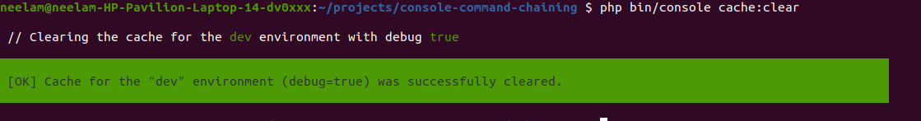
5. Now run the below command and see the output.
php bin/console foo:hello

6. Now when we run the below command

php bin/console bar:hi

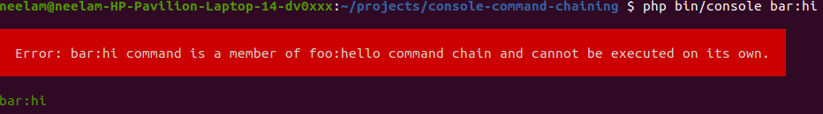
7. To run the PHPUnit test case.

php ./vendor/bin/phpunit

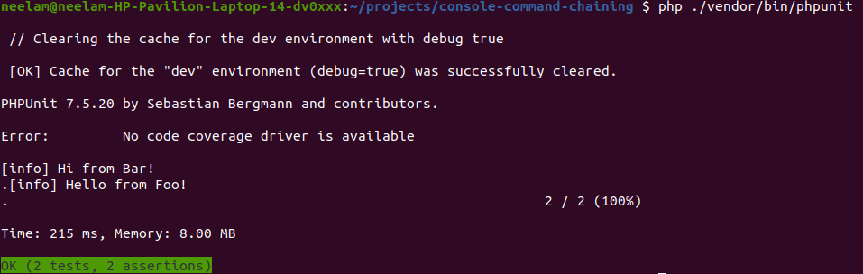

8. Logs can be found under /var/log/ folder. If the logger does not work make the logger public: false in services.yaml
